Grade 10 IB Bridging Year Chemistry

Topic 5 Stoichiometry

**5.4 Percentage yield**

The yield of a chemical reaction describes the amount of product obtained in moles/ mass.

The yield we expected to obtain is called the **theoretical yield**. It will always be larger than the **actual yield**. The percentage yield of a chemical reaction tells us how much product is actually made compared to the theoretical amount that could be made as a percentage.

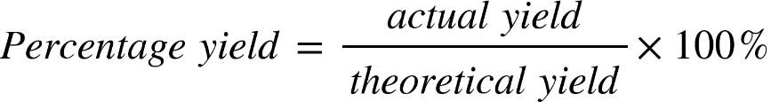

***Worked example***

A company collects calcium oxide from decomposition of limestone (calcium carbonate). It collects 98.0 kg of calcium oxide from 200.0 kg of limestone a day. What is the percentage yield of the process?

* CaCO3 (s) 🡪 CaO (s) + CO2 (g)
* No. of moles for 200 kg of limestone = 200 000 / (40.08+12.01+16x3)

= 1998 mol

* 1998 moles of limestone produces 1998 moles of CaO.
* Mass of CaO produced = 1998 x (40.08 + 16.00)

= 112 000 g

* Actual yield of CaO = 98 kg
* Theoretical yield of CaO = 112 kg

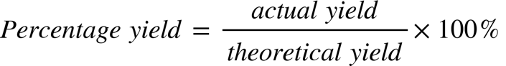

= 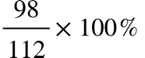

= 87.5 %

***Practice Exercise***

1. Chlorobenzene, C6H5Cl, is used in the production of chemicals such as aspirin and dyes. One way that chlorobenzene is prepared is by reacting benzene, C6H6, with chlorine gas according to the following balanced chemical equation.

C6H6 (l) + Cl2 (g) 🡪 C6H5Cl (s) + HCl (g)

* 1. What is the theoretical yield if 45.6 g of benzene react?

n(C6H6) = 0.5837 mol

n(C6H5Cl) = 0.5837 mol

m(C6H5Cl) = 65.7 g

* 1. If the actual yield is 63.7 g of chlorobenzene, calculate the percentage yield.

% = 97.0%

1. When carbon disulfide burns in the presence of oxygen, sulfur dioxide and carbon dioxide are produced according to the following equation.

CS2 (l) + 3 O2 (g) 🡪 CO2 (g) + 2 SO2 (g)

* 1. What is the percent yield of sulfur dioxide if the burning of 25.0 g of carbon disulfide produces 40.5 g of sulfur dioxide?

n(CS2) = 0.3283

n(SO2) = 0.6567

Theoretical Yield = 42.07g

% = 96.3%

* 1. What is the percent yield of carbon dioxide if 2.5 mol of oxygen react and 32.4 g of carbon dioxide are produced?

theoretical n(CO2) = 0.833mol

theoretical yield = 36.68g

% = 88.34%

1. a. Write a balanced equation for the reaction of tin (IV) phosphate with sodium carbonate to make tin (IV) carbonate and sodium phosphate.

sn3po44 + 6na2co3 -> 3snco32 + 4na3po4

1. When 36.0 g of tin (IV) phosphate is used, 29.8 g of tin (IV) carbonate can be obtained. What is the percentage yield of this reaction?

n(sn3po44) = 0.0489

n(snco32) = 0.1467

m(snco32)= 35.03

% = 85.07

1. Using a different set-up for the same reaction, 7.30 g of sodium carbonate is used in the reaction with a yield of 74.0%. How many grams of sodium phosphate will be obtained from the reaction?

15.03g